Columnar Model

🧱 What is the Columnar Data Model (or Column-Based Model)?
# Source: AI Source: Provided by: [Data Path: Persons Table -> ID Column: 1, Name_En Column: Motasem Essam] -> From: [ChatGPT] on [6/10/2026]
The Columnar Model is a data storage format where data is stored column by column instead of row by row. It's optimized for analytical queries that scan large volumes of data and access only specific fields.

🧠 How It Works
# Source: AI Source: Provided by: [Data Path: Persons Table -> ID Column: 1, Name_En Column: Motasem Essam] -> From: [ChatGPT] on [6/10/2026]
In a Row-based DB (like MySQL), data is stored like this:
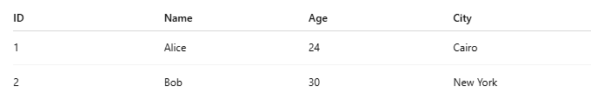
ID | Name | Age | City
1 | Alice | 24 | Cairo
2 | Bob | 30 | New York
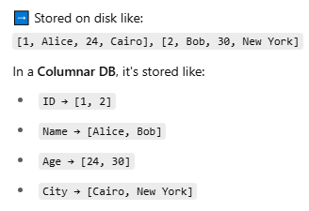
➡️ Stored on disk like:
[1, Alice, 24, Cairo], [2, Bob, 30, New York]
In a Columnar DB, it's stored like:
- ID → [1, 2]
- Name → [Alice, Bob]
- Age → [24, 30]
- City → [Cairo, New York]

✅ Best For
# Source: AI Source: Provided by: [Data Path: Persons Table -> ID Column: 1, Name_En Column: Motasem Essam] -> From: [ChatGPT] on [6/10/2026]
- 📊 Analytics and reporting
- 🔍 OLAP workloads (Online Analytical Processing)
- 🧪 Aggregate functions like SUM, AVG, COUNT

⚡ Advantages
# Source: AI Source: Provided by: [Data Path: Persons Table -> ID Column: 1, Name_En Column: Motasem Essam] -> From: [ChatGPT] on [6/10/2026]
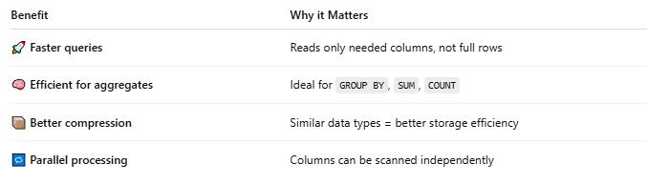
Benefit | Why it Matters
🚀 Faster queries | Reads only needed columns, not full rows
🧠 Efficient for aggregates | Ideal for GROUP BY, SUM, COUNT
📦 Better compression | Similar data types = better storage efficiency
🔁 Parallel processing | Columns can be scanned independently

❌ Disadvantages
# Source: AI Source: Provided by: [Data Path: Persons Table -> ID Column: 1, Name_En Column: Motasem Essam] -> From: [ChatGPT] on [6/10/2026]

Drawback | Why it's a Problem
🐢 Slow for row-level operations | Not ideal for frequent inserts/updates
🔧 Not great for OLTP | Bad for transactional apps (e.g. banking)
🛠 Limited schema changes | Changing schema on large columns is costly

🧱 Examples of Columnar Databases
# Source: AI Source: Provided by: [Data Path: Persons Table -> ID Column: 1, Name_En Column: Motasem Essam] -> From: [ChatGPT] on [6/10/2026]
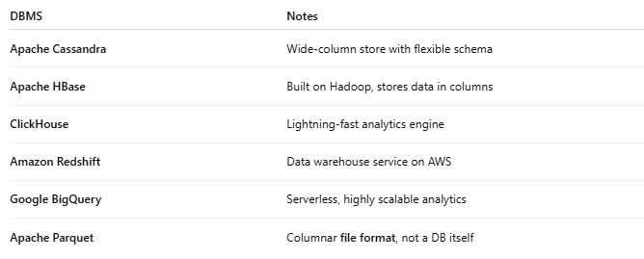
DBMS | Notes
Apache Cassandra | Wide-column store with flexible schema
Apache HBase | Built on Hadoop, stores data in columns
ClickHouse | Lightning-fast analytics engine
Amazon Redshift | Data warehouse service on AWS
Google BigQuery | Serverless, highly scalable analytics
Apache Parquet | Columnar file format, not a DB itself

🆚 Columnar vs Row-Oriented (Summary)
# Source: AI Source: Provided by: [Data Path: Persons Table -> ID Column: 1, Name_En Column: Motasem Essam] -> From: [ChatGPT] on [6/10/2026]
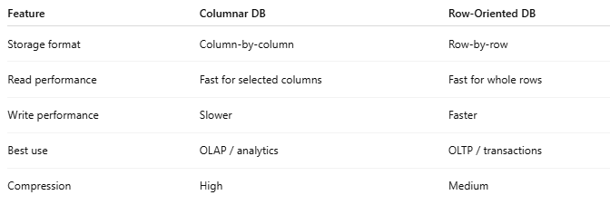
Feature | Columnar DB | Row-Oriented DB
Storage format | Column-by-column | Row-by-row
Read performance | Fast for selected columns | Fast for whole rows
Write performance | Slower | Faster
Best use | OLAP / analytics | OLTP / transactions
Compression | High | Medium

🆚 A visual diagram comparing column vs row storage
# Source: AI Source: Provided by: [Data Path: Persons Table -> ID Column: 1, Name_En Column: Motasem Essam] -> From: [ChatGPT] on [6/10/2026]
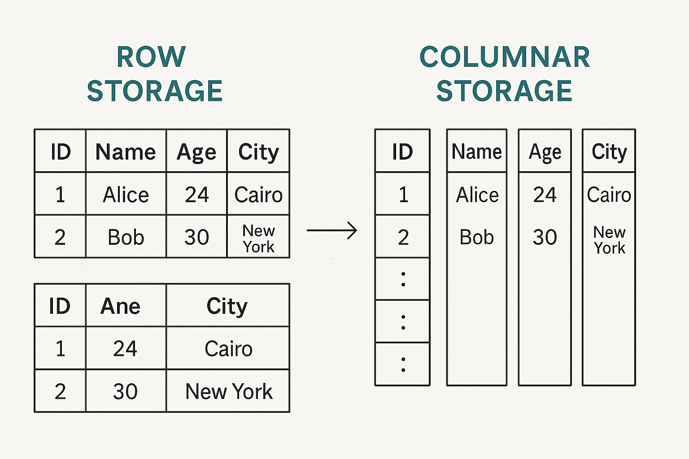

📚 Real-Life Use Cases
# Source: AI Source: Provided by: [Data Path: Persons Table -> ID Column: 1, Name_En Column: Motasem Essam] -> From: [ChatGPT] on [6/10/2026]
- 📊 BI tools (Tableau, Power BI)
- 🧾 Financial reports
- 🛒 E-commerce analytics
- 📈 Real-time dashboards

